**EXPERIMENT 2**

**Develop data flow diagram model (level-0,level-1 and level-2 DFD) of the system**

**What is a Data Flow Diagram (DFD)?**

A Data Flow Diagram (DFD) is a graphical representation of the flow of data through a system. It illustrates how data is input, processed, stored, and output in a structured manner. DFDs help in understanding, analyzing, and designing systems by breaking down processes into different levels of abstraction.

**Key Components of a DFD:**

* **Processes:** Represent functions or activities within the system.
* **Data Flows:** Indicate the movement of data between entities, processes, and data stores.
* **External Entities:** Represent users, systems, or components that interact with the system.
* **Data Stores:** Represent storage locations where data is held for processing.

1. **Level-0 DFD (Context Diagram) - Definition**

**Overview**

The Level-0 DFD, also known as the Context Diagram, provides a high-level overview of the entire system as a single process. It illustrates how the system interacts with external entities and the main data flows between them. The purpose of this level is to give a simplified representation of the system without detailing internal processes.

**Key Elements:**

* **External Entities:** Represent sources or destinations of data interacting with the system (e.g., users, administrators, third-party systems, databases).
* **Main System Process:** Depicts the system as a single entity that receives input, processes it, and provides output.
* **Data Flows:** Show how information moves between external entities and the system.

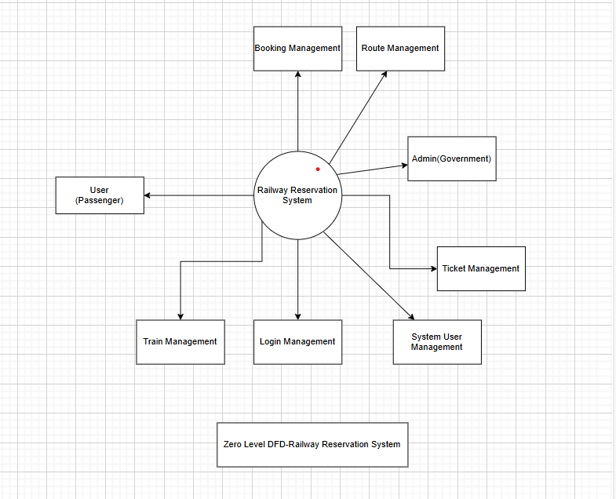

1. **Level-1 DFD - Definition**

**Overview**

The Level-1 DFD expands on the Context Diagram by breaking down the main system process into multiple sub-processes. This level provides more detail on how the system functions internally while still maintaining a high-level overview of the major operations.

**Key Elements:**

* **Processes:** Represent core functionalities of the system, such as authentication, transaction handling, and report generation.
* **Data Stores:** Identify where data is stored, such as user databases, transaction records, and logs.
* **Data Flows:** Show how information moves between processes, external entities, and data stores.

**Importance:**

* Helps stakeholders understand the system’s primary functions and their interactions.
* Provides a logical breakdown of the system’s major operations.
* Acts as a foundation for more detailed process breakdowns at the next level.
* 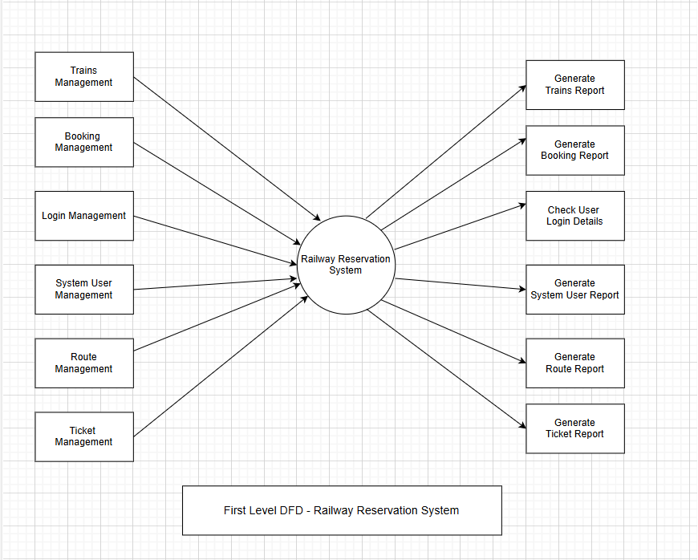

1. **Level-2 DFD - Definition**

**Overview**

The Level-2 DFD further decomposes one of the Level-1 processes to provide an even more detailed representation of how data is processed within the system. This level focuses on the specific internal sub-processes involved in carrying out a major function.

**Key Elements:**

* **Sub-processes:** Detailed breakdown of a Level-1 process into smaller components (e.g., order validation, payment authorization, and transaction logging within a transaction system).
* **Data Flows:** Show the flow of data between sub-processes, data stores, and external entities.
* **Data Stores:** More granular representation of where information is stored and retrieved.

**Importance:**

* Useful for system designers and developers to understand workflow at a micro-level.
* Identifies potential bottlenecks, security risks, and areas of optimization.
* Helps in system implementation by providing a roadmap for data movement and process execution.

